Software Requirements Specifications

Online Attendance Management App

Project Code:
SU19-223344

Internal Advisor:
Dr. Hassam Ali

Project Manager:
Dr. Muhammad Ilyas

Project Team:
Adeeba Ayesha  BSEF19M033 | Team Leader
Abdullah Manzoor  BSEF19M022 | Group Member
Bushra Iqbal  BSEF19M044 | Group Member

Submission Date:
11/15/2022

_____________________
Project Manager’s Signature
Document Information

Category | Information
Customer | CS & IT, UOS
Project | Online Attendance Monitoring App
Document | Requirement Specifications
Document Version | 1.0
Identifier | SU19-223344
Status | Draft
Author(s) | Abdullah Manzoor BSEF19M022  Adeeba Ayesha BSEF19M033  Bushra Iqbal BSEF19M044
Approver(s) | Dr. Muhammad Ilyas
Issue Date | Oct. 21, 2022
Document Location | University of Sargodha
Distribution | - Advisor  - PM  - Project Office

Definition of Terms, Acronyms, and Abbreviations

This section should provide the definitions of all terms, acronyms, and abbreviations required to interpret the terms used in the document properly.

Term | Description
AMS | Attendance Management System
SRS | Software Requirement Specification
XML | Extensible Markup Language
RAM | Random Access Memory
IDE | Integrated Development Environment
SDK | Software Development Kit
FS | Functional Specification

Table of Contents

1. Introduction 5
1.1 Purpose of Document 5
1.2 Project Overview 5
1.3 Scope 5
2. Overall System Description 5
2.1 User characteristics 5
2.2 Operating environment 5
2.3 System constraints 6
3. External Interface Requirements 6
3.1 Hardware Interfaces 6
3.2 Software Interfaces 6
3.3 Communications Interfaces 6
3.4 User Interfaces 7
4. Functional Requirements 7
5. Non-functional Requirements 7
5.1 Performance Requirements 7
5.2 Security Requirements 7
6. Assumptions and Dependencies 8
7. System Architecture 8
8. Use Cases 9
8.1 Use Case Diagrams 9
8.2 Use Case Description 11
9. Graphical User Interfaces 12
10. High-Level Design 15
10.1 ER Diagram 15
10.2 Data Dictionary 16
10.2.1 Data 1 16
10.2.2 Data 2 16
10.2.3 Data 3 17
11. Requirements Traceability Matrix 17
12. Risk Analysis 18
13. Cost Estimation Sheet 19
14. References 19
15. Appendices 20

Introduction

  - Purpose of Document
The purpose of SRS is to collect and analyze all assorted ideas that have come up to define the system, we hope the document will be used to gain a better understanding of the project. The outline concept and ideas that will be developed may be discarded during the development phase. The contents are intended to be utilized by CS & IT department and developers as guidelines for implementation and testing. Also, the engineering professor evaluates the software’s design and features.

  - Project Overview
Apparently, in today’s world things cannot be done organized, accurately, and efficiently using a file-based system so making things globally in a digitized way is a tremendous advantage. Online AMS has two main modules of functioning: First is Admin (Head Office) who has the right to enter new faculty members (Details of the member would be registered on the admin side) and can access the attendance report of all the faculty. Second is the User (Teacher) who has the right of marking daily attendance and can view attendance. The objectives and benefits of using this system are eliminating duplicate data entry and errors in attendance entries, eliminating paperwork, and saving time. Automatic calculation of attendance increases security.

  - Scope
The proposed Attendance Monitoring System is designed and developed for the Universities. The design and platform of the project is a mobile-based system to manage user and client registration and provides the functionality of recording the individual records of teacher attendance. The system also provides a search capability and also helps the admin maintain and track attendance through the location of employees.

Overall System Description
The Attendance Management System is intended to replace the manual model of attendance record keeping using paper records. Teachers will be able to mark their attendance by location authentication and can view their details regarding attendance on their mobile. The features expressed in this SRS document are intended to be fully implemented in version 1.0. The system will be developed in such a way as to provide easy addition of enhanced features, which may be desired in subsequent versions.

  - User characteristics
This system will be used in two modules. Both of these have different requirements the modules are required to meet their needs and are important. The uses of these user modules are described below:

- Head Office
Add, update and delete Attendance details.
Can add, update, and delete faculty details.
See attendance detail.
Generate attendance report.
- Faculty Members
Mark attendance after authentication.
View attendance report.

  - Operating environment
The Online-AMS will function on the mobile operating environment. This entails the system’s operating on the Android platform. The Online-AMS will interface in android, designated to store the attendance records. This system has some requirements to accomplish. It needs hardware requirements for developing purposes and software for operating.
Hardware requirement:
  - 3 GB RAM minimum, 8 GB RAM recommended (plus 1 GB for the Android Emulator)
  - 2 GB of available disk space minimum, 4 GB recommended (500 MB for IDE plus 1.5 GB for Android SDK and emulator system image)
  - 1280 x 800 minimum screen resolution.
Software requirement:
  - Android Studio
- Microsoft Windows 7/8/10 (32-bit or 64-bit)

  - System constraints
The following are constraints or limitations of the system. Constraints may include the following:
- The user (Teacher) can log in with his assigned username, no guest facilities are available.
- Users can mark attendance only when the location is ON.
- A minimum of 2 GB RAM is required to develop the application.
- The interface is only in English.
- It requires an internet connection to use the application in any environment.
- The project is developed for only educational departments.

External Interface Requirements
These include user interfaces, layout, buttons, and functions on-screen, hardware interfaces, software interfaces, and other relevant particularities.

  - Hardware Interfaces
Hardware Environment | Intel(R) Core (TM) m5-6Y54 CPU @ 1.10GHz 1.50 GHz
System Configuration | 8.00 GB RAM
OS | Windows 10 Pro, 21H2 64-bit operating system, x64-based processor
Control Interactions | Mouse, Pen, and touch support with 10 touchpoints

  - Software Interfaces
Tools | Android Studio
Front End | XML
Back End | JAVA
Database | Firebase Database

  - Communications Interfaces
CI-1: The security of a user must be consistent through the use of passwords.
CI-2: The Attendance Management System will communicate to the database through
Internet.

  - User Interfaces
UI-1: The Attendance Management System shall provide details of teachers in the department to aid in taking roll.
UI-3: All modifications to the database will be done through a keyboard.
UI-4: The application will be accessed through a Browser Interface. The interface would be viewed using 1024 x768 and 800 x 600 pixels resolution settings.

Functional Requirements
Employee Attendance Monitoring System by GPS involves the following functions:

Adding Staff
- The system must be able to add new staff members.
- The new member must be registered on the admin side before login into the system.
Attendance management
- The system must be able to easily track the attendance information of employees.
- The system must store and represent the attendance of employees.
- Without turning ON the location, the system must not be able to mark attendance.
- The system properly fed into the system.
- Everyone should be able to view their attendance.
- The system would alert the shortage of the attendance of particular employees.
Other requirements
- The system must include the functions of admin and employees like login, register, attendance list, regular check-in, and update.
- Admin should be able to update attendance details.
- Leave management is another area where the system would a play role, the employee would be alerted to apply for leave.
- The system could be able to determine the current time.
- If an employee is not coming, the system would have a feature to apply for leave.

Non-functional Requirements

  - Performance Requirements
PR-1: The program should be able to be run concurrently by multiple professors. During peak times of usage.
PR-2: Transmission of roll data shall occur in under 5 seconds. It would be fast enough to produce output the system shall be highly robust.
PR-3: The UI of the system should be very simple and harmonic, color combination of light and dark is emphasized and done well on the system. The forms should make simple for a good user interface.
PR-4: The program shall support taking rolls for sizes of up to 1000. With a maximum user size, performance must still conform to all performance requirements.

  - Security Requirements
SR-1: Inside the system, there are faculty members and head office staff who are going to use the system. The main users of the entity are teachers. Faculty members must use the entity every day by turning on their location by the beginning of each class.
SR-2: The head office staff will be able to use the entity to control attendance, their job is to add, edit, update and delete any record. Furthermore, they will check on every faculty member’s identification for security purposes.

  - Safety Requirements
The system would be protected by a password so that no guest could be able to enter the system.

Assumptions and Dependencies
We assume that the Office personnel does all the data entry and registration of users.
We assume that the device that will use the software will be part of the college (for the admin side only).
Users with administrator access should be careful in deleting or modifying any information knowingly or unknowingly which will lead to inconsistency in the database.

System Architecture
The online location-based attendance management system is a client-server approach. This system will locate the position of the user. The software architecture shown in the diagram consists of the database and the application program.
Process 1.0: Login
This module allows the lecturer and admin to login into the system and uses the system. The users need to enter their username and password before using the system. This will ensure that only authorized users will have the access to enter the system.
Process 2.0: Mark Attendance
In this module, only the lecturer will be involved. After the lecturers have logged on, they will have to ON mobile location to mark attendance. Subject information will be retrieved from the Subject and the teacher will mark attendance.
Process 3.0: Processing
This module happens when all the criteria are met to consider the attendance of the student. If there are no errors occur, the attendance will be stored in a database.
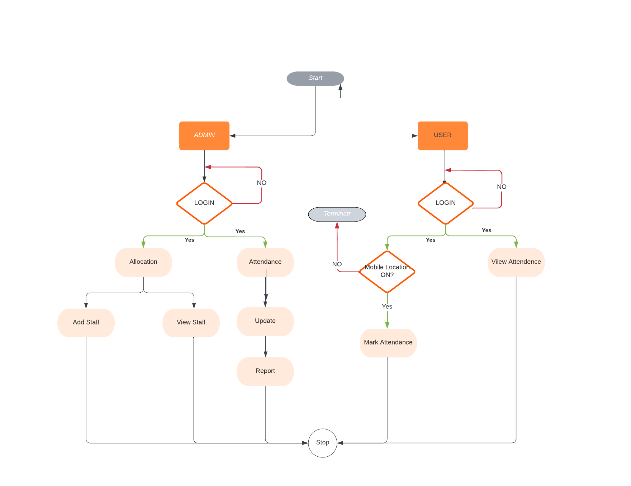

Data Flow Figure 7.1

Use Cases

  - Use Case Diagrams
In this section, use case diagrams using the UML convention are provided.
Teacher use-case diagram

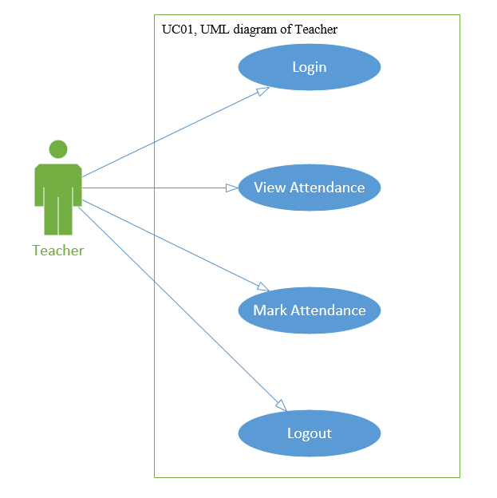

Admin use case diagram

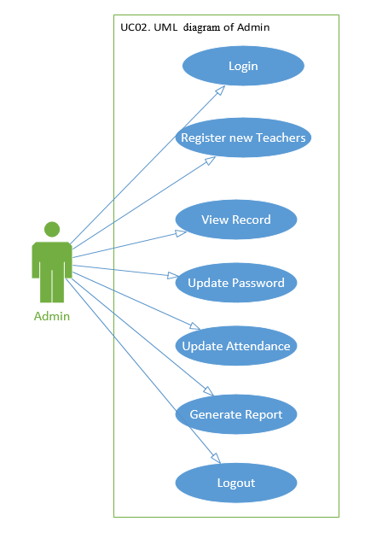

Mark Attendance use case diagram

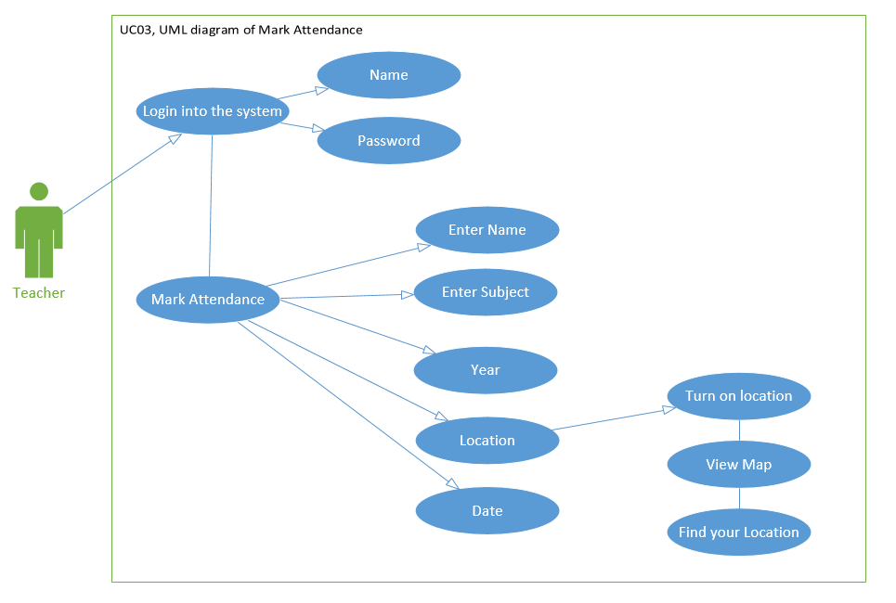

AMS use case diagram

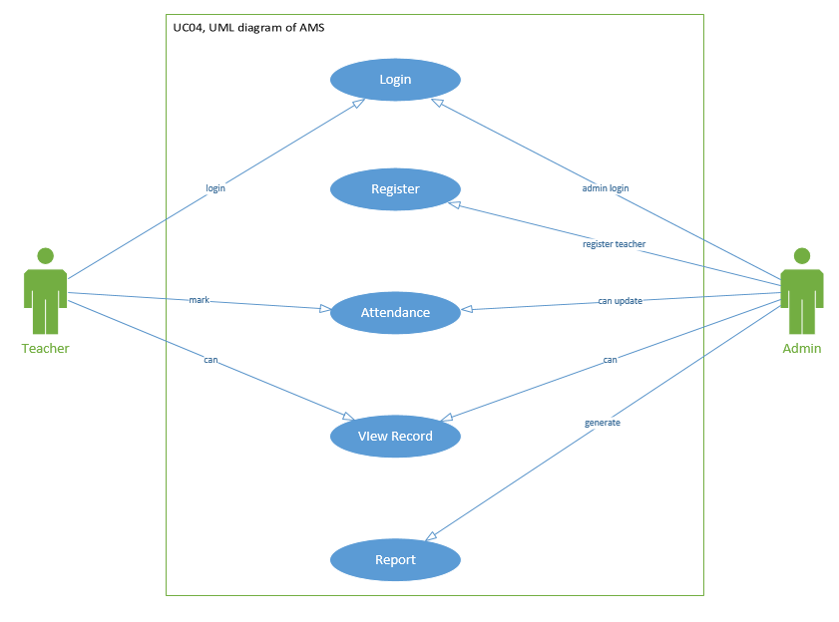
  - Use Case Description
Each Use Case has a description, which describes the functionality that will be built into the proposed system.

Use case Id: Register
Actors: Head Office (Admin)
Feature: The head office will register teacher information
Use case Id: |  | UC02, UC04
Pre-condition: |  | The teacher must be employed in the school
Scenarios
Step# | Action |  | Software Reaction
1. | Every teacher will be registered. |  | The teacher will receive a unique id to log in to the system.
Post Conditions
Step# | Description
 | The teacher added a new member

Use case Id: Mark Attendance
Actors: Teacher, Head office staff
Feature: The teacher will mark attendance
Use case Id: |  | UC03
Pre-condition: |  | The teacher must have an Identification number provided after registration.
Scenarios
Step# | Action |  | Software Reaction
1. | The teacher will be able to mark attendance. |  | The teacher will have daily attendance.
Post Conditions
Step# | Description
 | If the precondition is met, then the teacher will enter the id number and mark attendance.

Use case Id: View Record
Actors: Teacher, Head office staff
Feature: The teacher can view their attendance details.
Use case Id: |  | UC04
Pre-condition: |  | To view attendance records, they must present their identification cards to the teacher will search for their attendance details.
Scenarios
Step# | Action |  | Software Reaction
1. | The teacher will ask for access. |  | The teacher will be able to view attendance.
Post Conditions
Step# | Description
 | If the precondition is met, then the teacher will search for attendance details.

Use case Id: Generate report
Actors: Head office staff
Feature: The staff will create a report on teachers.
Use case Id: |  | UC04
Pre-condition: |  | The staff must log in as administrators and access the report form
Scenarios
Step# | Action |  | Software Reaction
1. | The report will be provided to the administrator. |  | The teacher will be able to view attendance.
Post Conditions
Step# | Description
 | If preconditions are met, then the staff creates the report specific to teachers.

Graphical User Interfaces

User Interface Id: Log In
Interface Id. |  | UI01
Use case Reference |  | UC04
Snapshot
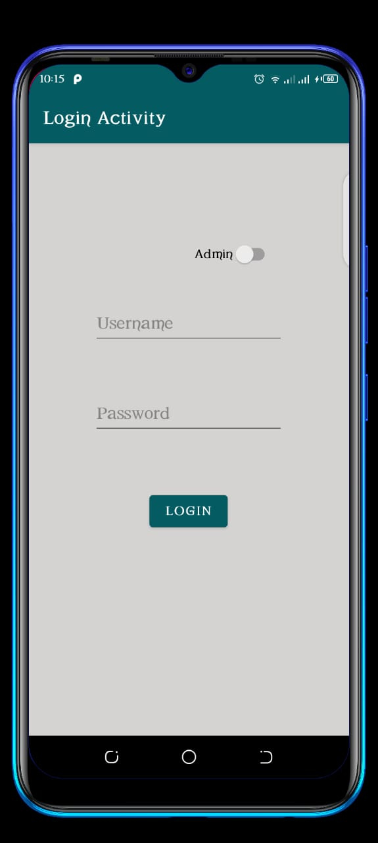\
Data dictionary reference
Label | Login
 | Table 10.2.1 data design for Login

User Interface Id: Teacher Registration
Interface Id. |  | UI02
Use case Reference |  | UC02
Snapshot
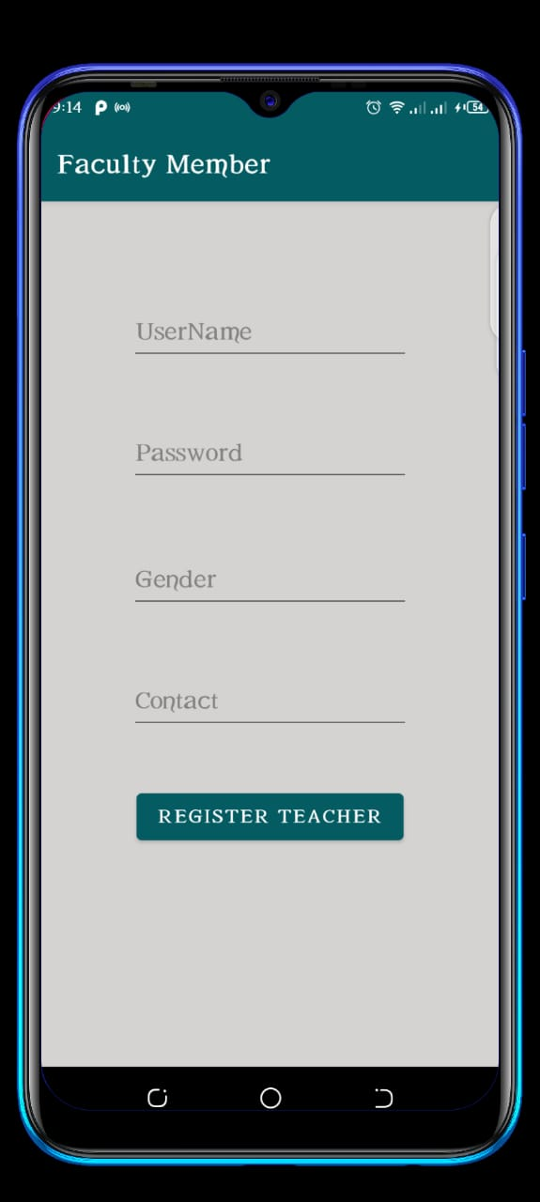
Data dictionary reference
Label | Teacher Registration
 | Table 10.2.2 data for Teacher Registration

User Interface Id: Attendance Mark
Interface Id. |  | UI03
Use case Reference |  | UC03
Snapshot
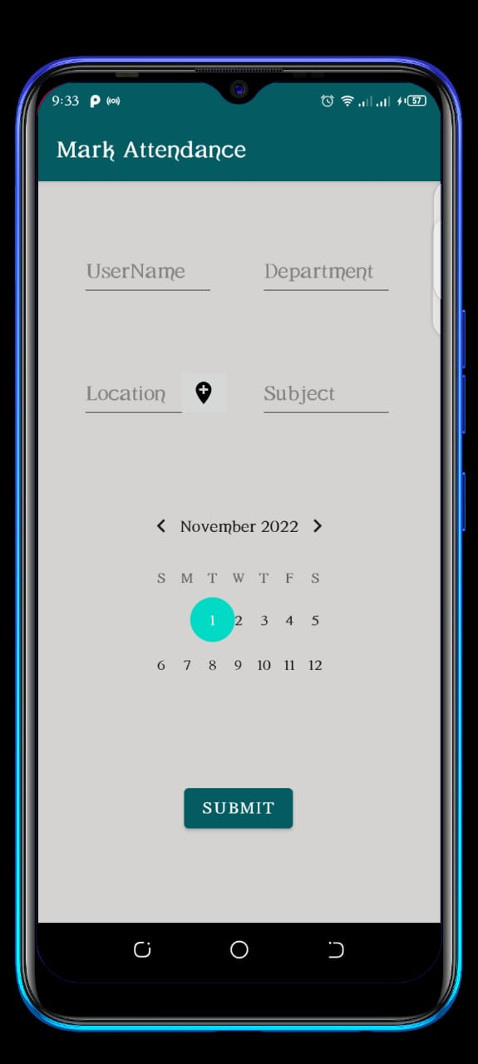
Data dictionary reference
Label | Teacher Attendance
 | Table 10.2.5 data for Teacher Attendance

User Interface Id: Attendance Sheet
Interface Id. |  | UI04
Use case Reference |  | UC04
Snapshot
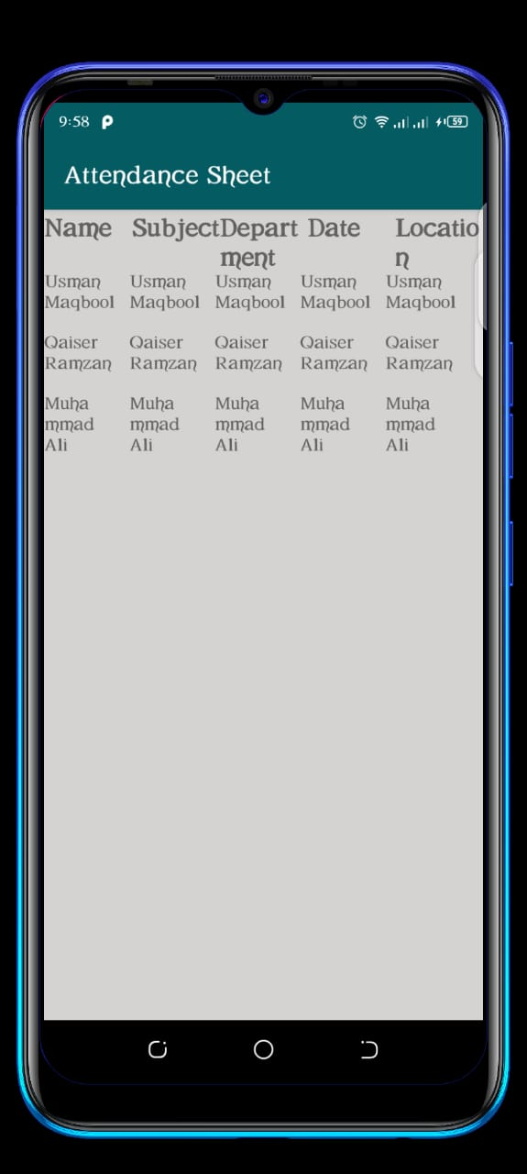\
Data dictionary reference
Label | Attendance Sheet
 | Table 10.2.5 data for Teacher Attendance sheet

High-Level Design

  - ER Diagram
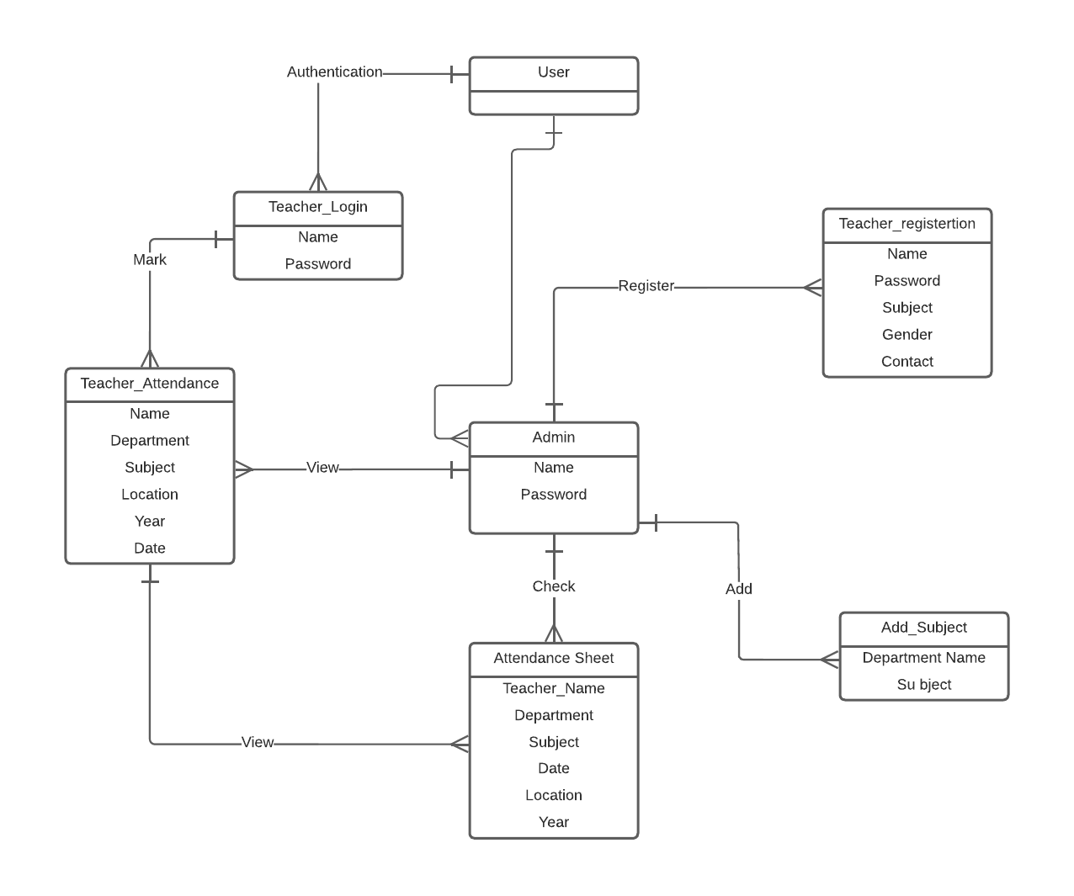
Entity relationship diagram EI-1

  - Data Dictionary
The convention recommended for writing the data dictionary is as follows:
- Table Login
- Table Teacher Registration
- Table Teacher Attendance
- Table Attendance Sheet

    - Data 1
Table 10.2.1 data for Login
Name | Data Type | Field Size | Content Description | Example
Username | Varchar | 20 | Unique username(email) | abc@gmail.com
Password | Varchar | 8 | Password must contain at least 8 characters | 98765432

    - Data 2
Table 10.2.2 data for Teacher_Registration
Name | Data Type | Field Size | Content Description | Example
Username | Varchar | 20 | username(email) | Usman Maqbool
Password | Varchar | 8 | Password must contain at least 8 characters | 12345678
Subject | Char | Not Null | The name of the subject will be registered | Software Engineering
Gender | Char | Not Null | Must have to select at least one gender | Male
Contact | Int | 11 | At least 11 digits | 03123456789

    - Data 3
Table 10.2.5 data for Teacher Attendance
Name | Data Type | Field Size | Content Description | Example
Name | Varchar | 20 | Unique username(email) | abc@gmail.com
Department | Varchar | 8 | Password must contain at least 8 characters | 12345678
Subject | Varchar | Not Null | The teacher will add assigned the subject | Software Engineering
Location | Varchar | Not Null | The current location will be tracked | Abc, city, area
Year | int | Not Null | Current year | 2022
Date | int | Not Null | Current date | 10/31/2022

Requirements Traceability Matrix

Sr. # | Feature | Use case ID | UI ID | Priority | Build Number | Use Case Cross reference  (Related Use Cases)
01 | The teacher can log in (FS-9) | UC01 | UI01 | 5 | 1 | The teacher can log in by entering name their and password
02 | Teacher mark attendance (FS-5) | UC03 | UI03 | 4 | 1 | The teacher can mark the attendance by GPS
03 | The teacher can view the attendance (FS-7) | UC01 | UI04 | 5 | 1 | Through attendance sheet
04 | Admin can log in (FS-9) | UC04 | UI04 | 5 | 1 | The teacher can log in by entering their name and password
05 | Admin can view record (FS-7) | UC04 | UI02 | 3 | 1 | Of teachers
07 | Admin generates a report (FS-4) | UC04 | UI04 | 2 | 1 | By checking the Attendance sheet
08 | Admin can register (FS-2) | UC04 | UI01 | 5 | 1 | Admin can register record if new teacher enrolls

Risk Analysis
Every application face, an unexpected event that can affect the project, which can affect people, processes, technology, and resource. Here is a list of risks that may occur during the project:

Technical Risk
- Social engineering is a common attack, in which an email or phone call may ask you to call a number to discuss a problem with your account. You might then be asked to reveal account details over the phone. In this way, the attacker can access the password of the system and can make changes in the system.
- Another risk that may occur is pretexting, which involves the creation of a fake identity or scenario to fool a person into disclosing information. The attacker may email as app owner and ask for a password and username.
- A computer virus is a program designed to replicate through the internet, damage programs, and delete files or other system resources.

Risk Drivers
- Time risk, also known as project schedule risk, is the risk that tasks in your project will take longer than expected. Delayed timelines might impact other things like your budget, delivery date, or overall performance. This is a common risk that you may run into with a project manager.
To mitigate time risk, a rule of thumb is to overestimate the time needed to complete tasks in the planning phase and build in time contingency. That way, you’ll have wiggle room for scheduling later on. You can also create a project schedule using a Timeline or Gantt chart.
- Resource allocation
Resource risk occurs if you don’t have enough resources to complete the project. Resources may include time, skills, money, or tools. As a project manager, you’re responsible for the procurement of resources for your team and communicating with your team about the status of resources.
The best way to mitigate resource risk is to create a resource allocation plan. A resource allocation plan makes the best use of team resources while maximizing resource impact and supporting team goals.
- Lack of clarity
Lack of clarity may result in miscommunication from stakeholders, vague project scopes, or unclear deadlines. The result can be a lack of visibility due to soloed work, going over budget, or falling behind project deadlines.
When planning your project, check and recheck your requirements to ensure everything is in place.

We are using a risk avoidance plan which we find effective and valuable for our project:

Modeling the cost of risk avoidance
A project economic model is an important tool in deciding to eliminate a requirement or extend the schedule a little to take time to mitigate the associated risks. Differentiating the value of each requirement (e.g identifying each requirement as a ’must’, ’should’, or ’could’) is also important, as it provides the basis on which to make the best decisions.

Modularizing product architecture to mitigate risk
One way to mitigate risk is the modularization of product architecture to isolate the risky areas. By isolating the areas, we have to change more times, we can change them more quickly.
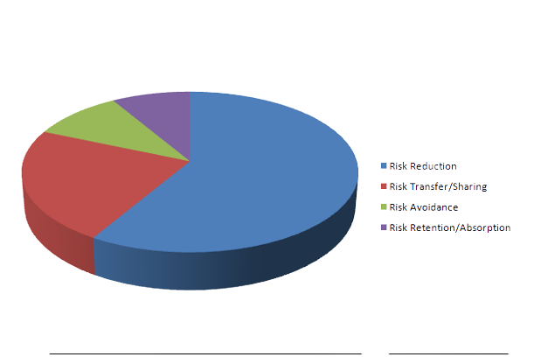

Cost Estimation Sheet
 | Software development cost | 1108677
 | Packaged software | 5544
 | Hardware | 27900
 | Network | 50000
 | Client | 15000
 | Misc. | 50000
 |  | Total cost =1257121

References

alam, m. (n.d.). Attendance management system project documentation. 83.
attendance management system. (n.d.). Retrieved from lovelucoding: https://www.lovelycoding.org/attendence-management-system/
Attendance Monitoring System Thesis. (2019, October 15). Retrieved from itsourcecode: https://itsourcecode.com/fyp/attendance-monitoring-system-thesis/
b. o. (n.d.). SRS of attendance management. Software requirement specification, 7.
Ex, O. (2013). STUDENTS ATTENDANCE MANAGEMENT SYSTEM MINI PROJECT REPORT MASTER OF COMPUTER APPLICATIONS. Student attendance management system, 67.
Maurya, V. (n.d.). Software Requirements Specification For Attendance management system. Attendance management system, 21.
Muhammad, A., Elmi, M. H., & M. M. (2016, November 08). Retrieved from http://103.82.172.44:8080/xmlui/bitstream/handle/123456789/92/Attendance%20Management.pdf?sequence=1&isAllowed=y
Sharma, V., & Raval, G. (2013). Attendance Management System. 11.
Suraya, N. B. (2018). ATTENDANCE SYSTEM BASED ON LOCATION. 59.
Adele, O. (n.d.). Project Proposal On Mobile Attendance Management System. Retrieved from Scribe: https://www.scribd.com/document/544915475/PROJECT-PROPOSAL-ON-MOBILE-ATTENDANCE-MANAGEMENT-SYSTEM
Attendance Management System Project Proposal. (2022, March). Retrieved from itsourcecode: https://itsourcecode.com/wp-content/uploads/2022/03/Attendance-Management-System-Project-Proposal.pdf
Mondal, J. (2019). Students attendance management system data part 2. Retrieved from Academia: https://www.academia.edu/38598793/Students_attendance_management_system_data_part_2
Oqbah, M., Alhothaily, M., El-Kustaban, A. M., & Alradaey, M. (2015). Fingerprint Attendance System for Educational Institutes. Retrieved from Researchgate: https://www.researchgate.net/publication/304216847_Fingerprint_Attendance_System_for_Educational_Institutes#:~:text=Fingerprint%20attendance%20system%20aims%20to,traditional%20name%20call%20out%20procedures.
SohaibQaisar. (2017, September 25). Student Attendance Management System IT-UOG -Project Management Office Version: 1.0 Project Proposal Guide. Retrieved from Academia: https://www.academia.edu/35759430/Student_Attendance_Management_System_IT_UOG_Project_Management_Office_Version_1_0_Project_Proposal_Guide
Ujan, I. A. (2011). Biometric Attendance System. Biometric Attendance System, 1-4. Retrieved from https://itsourcecode.com/wp-content/uploads/2022/03/Attendance-Management-System-Project-Proposal.pdf

Appendices
SRS: Software Requirement Specification
RAM: Random Access Memory
OS: Operating system
DB: Databases
XML: Extensible markup languages

